HW2 – Multiple Testing Data-Screenshot for each year

YEAR 2016

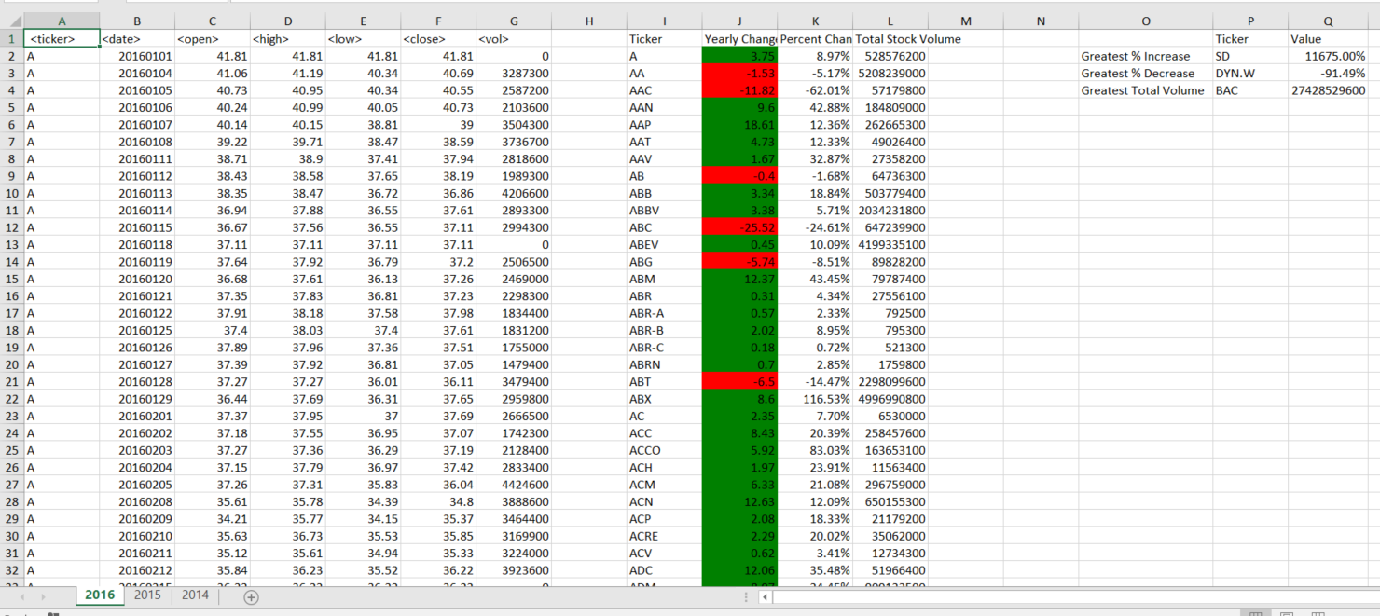

YEAR 2015



